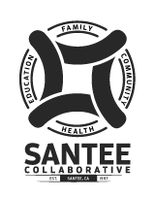 NOTICE OF MEETING SANTEE COMMUNITY COLLABORATIVE
The Mission of the Santee Collaborative is to promote a healthier, proactive community that builds resilient children and families.

DATE: Wednesday October 25, 2023
TIME: 3:00 PM – 4:30 PM
PLACE: 9619 Cuyamaca Street, Santee, CA 92071 – Boardroom

The business to transact at the meeting shall be limited to the following:
- Welcome – Ken Fox 05

- Agenda and Minutes 05
  - Approval of Agenda
  - Approval of Minutes for June 28th, 2023

- Public Communication – All

- Fleet Science Center - Yanet Lopez 15

- Jewish Family Services, Triple P Program - Julio Ramos 30

- Director’s Report – Janessa Nedney 10

- Announcements/Resources/Concerns – All 30

- Adjourn

Next Collaborative Meeting – Wednesday, November 15th, 2023, at 3:00 p.m.

